IU South Bend and IU Foundation Online Scholarship Application
Apply to more than 200 IU South Bend Scholarships (Institutional, Alumni, Departmental, and Foundation Scholarships) by submitting your Online Scholarship Application (OSA) before March 1st 11:59 pm EST each year. OSA opens on October 1st each year.
If you a continuing student, proceed to step 3.
If you are a new student and have been admitted to IU South Bend and have your One.IU.edu account already setup, proceed to step 3.
- If you have not yet applied to IU South Bend, submit your admission application immediately. Visit Apply Now. If you have already applied, and are waiting for an admission decision, contact the Office of Admissions to learn about the status of your admission application.
- Once you have been admitted to IU South Bend, you will receive log-in information to create your first One.IU.edu account. You need this account to begin the OSA! If you need help in creating the account, visit orientation.iusb.edu and follow steps 1 and 2. After creating the account, go to the next step.
- Go to One.IU.edu Click ‘Sign in’ on the top right as shown in the image below. Now login to your account using your account username and passphrase.

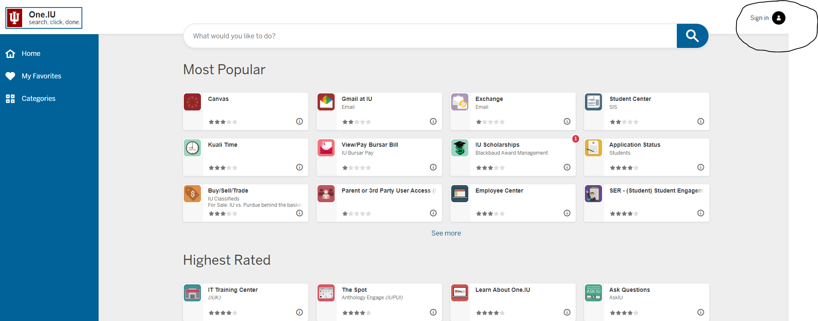

- After logging, click on the Search box and type 'scholarships’ as shown in the image below.

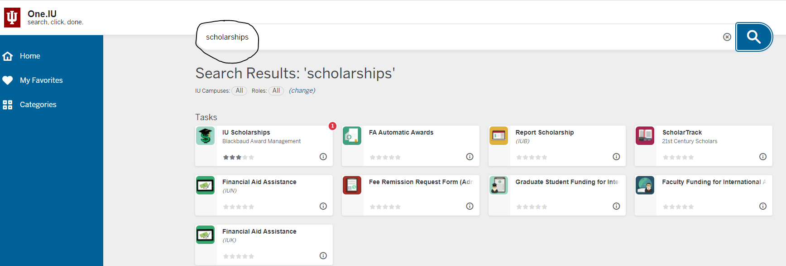

- Click the first tile 'IU Scholarships' that appears and it should take you to the next page.
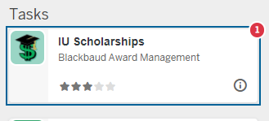

- Now click the ‘start’ button
- If you have logged in, the IU General Application will open as your landing page.
- Complete filling the application. Please save your work often. Without any save action your session will timeout after 15 minutes. Once you submit your application, you will no longer be able to make further changes.
  - Once completed, Click the “Finish and Submit” button NO later than March 1st 11:59pm EST!
- Congratulations! Now you have submitted your general scholarship application.
  - You will get an email to your IU email to apply for additional recommended scholarship opportunities based on your general application. Go back to Step 3, and log back into the system, and apply. If you need help contact the Office of Financial Aid and Scholarships at scholar1@iusb.edu
  - Many scholarship and financial aid options require you to have a FAFSA on file, so we recommend completing yours as soon as possible (before March 1st). Visit Complete Your FAFSA
- If you are a new student to IU South Bend
  - To secure scholarship offerings, you must confirm your admission to IU South Bend by May 1st. Visit admissions.iusb.edu after March 1st to confirm.
  - After confirming, Signup to attend the New/Transfer Student Orientation and register for classes. Visit orientation.iusb.edu and follow the steps.
For more information on exploring and applying for scholarships, visit our Scholarship Resources page.
Important Dates
OSA Opens: October 1st
OSA Closes: March 1st
Admission Confirmation date to secure scholarship offerings: May 1st
Students must confirm their admission by May 1st to be considered for all institutional scholarships. If you have questions, contact Admissions at 574-520-4839 or admissio@iusb.edu
For additional information regarding the scholarships, please e-mail Student Scholarships by filling out the form online, or email scholar1@iusb.edu or call (574) 520-4357 (toll free: 1-877-462-4872 extension 4357).

