Note-taking
Preparation

- Use a large, loose-leaf notebook.
- Use only one side of the paper (for legibility and to lay your notes out to see the direction of the lecture).
- Draw a vertical line 2 ½ inches from the left side of your paper.
  - This is the recall column. Notes will be taken to the right of this margin.
  - Later, key words or phrases can be written in the recall column.

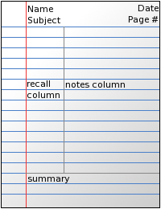
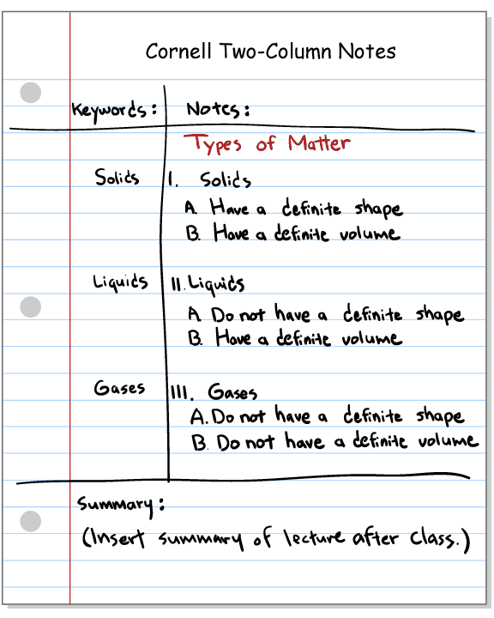
Take Notes

- Write the following information in the top right-hand corner of the page:
  - Class, Topic, Date, and Page Number (include the date and page number on every sheet of a day’s lecture).

- In the larger, right-hand column on your notebook paper, take notes during the lectures using the following techniques:
  - Skip spaces to show changes of topic and to leave room for later insertions or edits.
  - Indent to show subtopics and details.
  - Abbreviate common words (such as “because” or “and”) and other frequently used words (words that are related to the course topic), and eliminate articles (such as “the” or “a”) to save time and to record more information.
  - Leave blanks for words, phrases or ideas you think you may have missed.
    - Directly after class, ask the instructor or another student to help you fill in the blanks, and then complete and clarify your thoughts.

Edit Notes

- Underline or highlight important information.
- Edit your notes after class that day by writing the major topics, key terms, and questions (“trigger words”) in the small, left-hand column.
- Rewrite unclear sentences and fill in incomplete thoughts rather than taking the extra time to recopy your set of notes.

Review Notes

- Periodically review your notes by covering the right-hand column and quizzing yourself from the trigger words you wrote in the left-hand column.
- When preparing for an exam, review every trigger word.
  - Place a checkmark by information you have mastered. Information you cannot recall should be studied further.
  - Continue studying until you have check-marked every trigger word—indicating mastery of all of the material.

Use symbols and abbreviations to help you take notes faster:

= same or equal
$≠$ not equal
> greater than
< less than
~ approximately
$∴$ therefore
up or increasing

down or decreasing

resulting in
* most importantly
e.g. for example
i.e. that is
w/ with
w/o without
w/in within
b/c because
v very
esp especially
min minimum
cont’d continued

